1.a,b

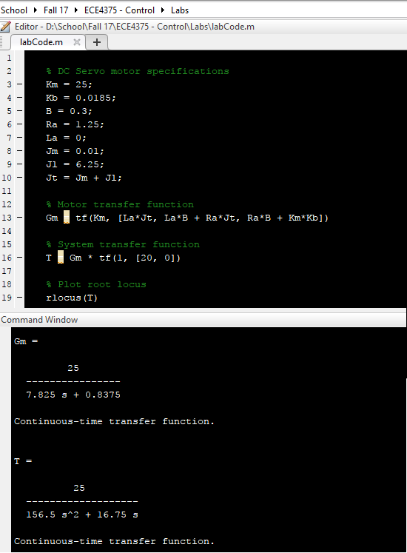

Figure MatLab calculation of transfer functions

1.c

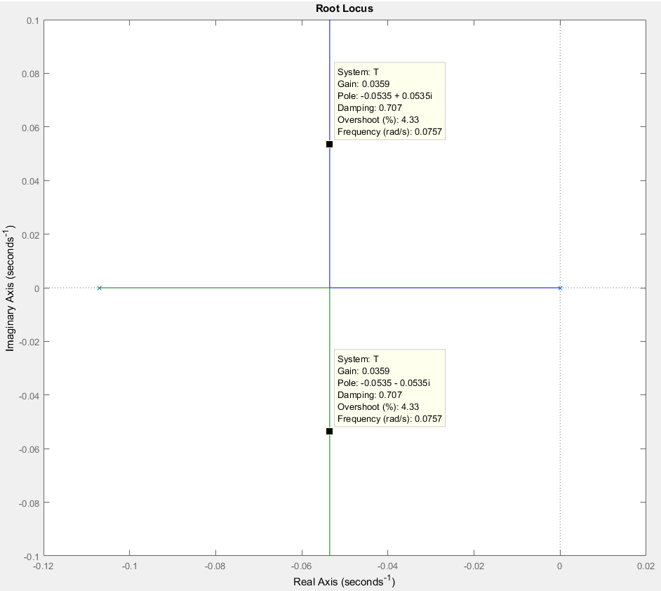

Figure MatLab Root Locus Plot

1.d KP = 0.0359

1.e

1.f

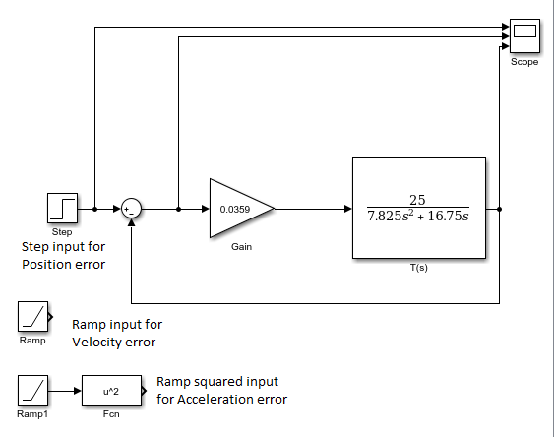

Figure Simulink Block Diagram

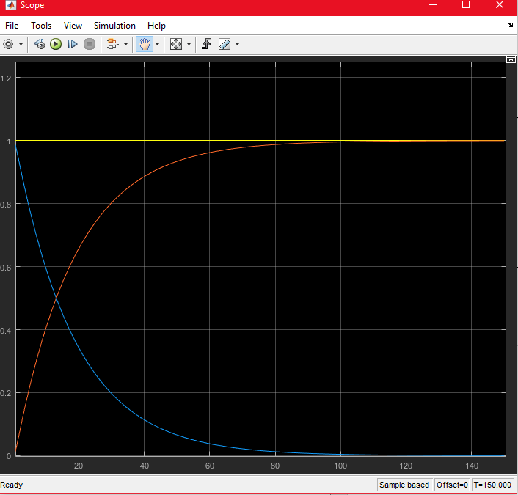

Figure Static Position error. Yellow: Input, Orange: Output, Blue: Error.

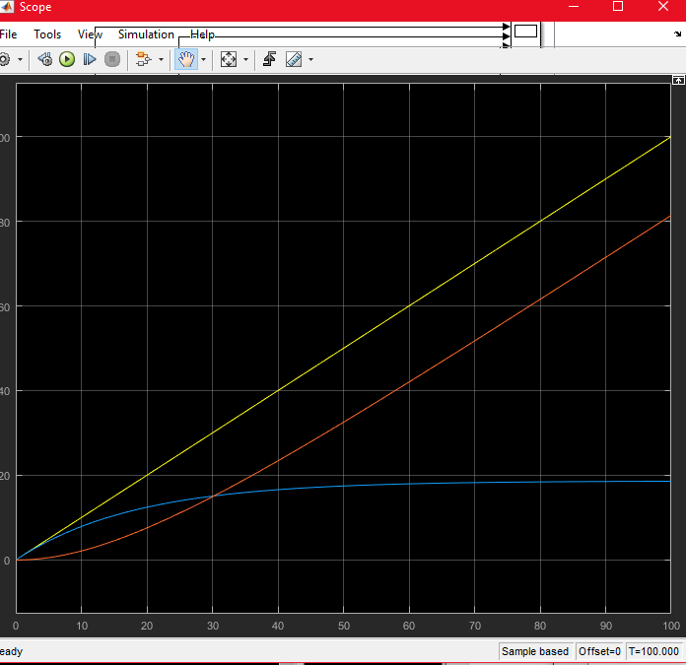

Figure Static Velocity Error. Yellow: Input, Orange: Output, Blue: Error

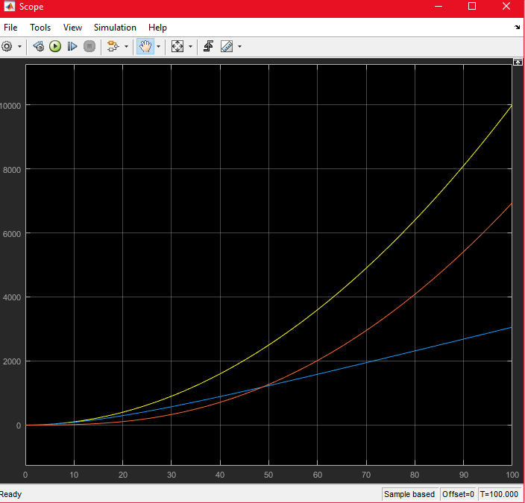

Figure Static Acceleration Error. Yellow: Input, Orange: Output, Blue: Error.

a.

Controller in (d) has less overshoot and less oscillation, so unless you want the system to reach a target value quicker, the controller in (d) performs better.

b.

The gearbox reduces the motor output by a factor of 20

c.

The output of the system oscillates at the same frequency as the input, but experiences greater attenuation at higher frequencies.

2

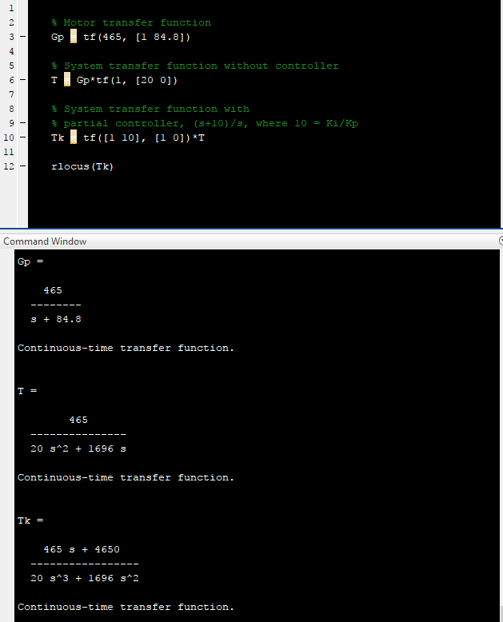

Figure Matlab code for transfer functions

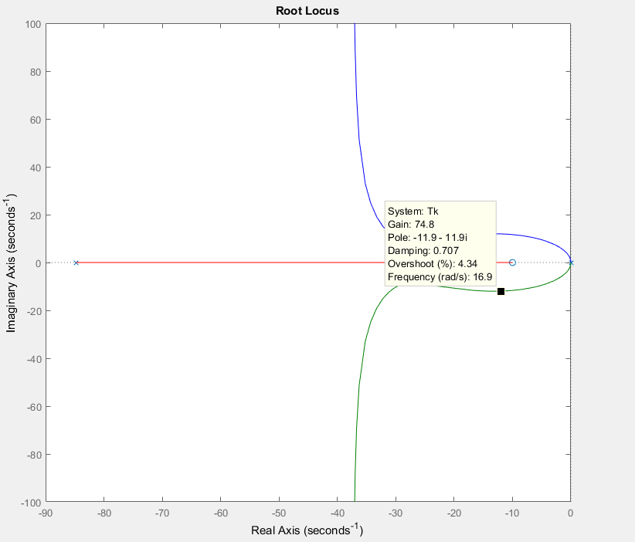

Figure Root Locus Plot

(a)

KI/KP was chosen to be 10, resulting in:

and

So

(b)

For KI/KP = 10:

Then

(c)

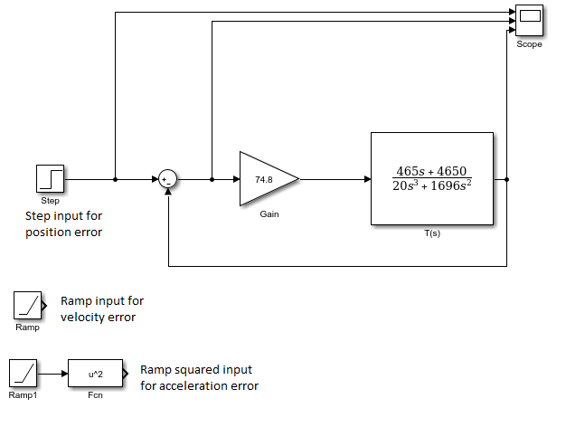

Figure Simulink diagram for static error plots

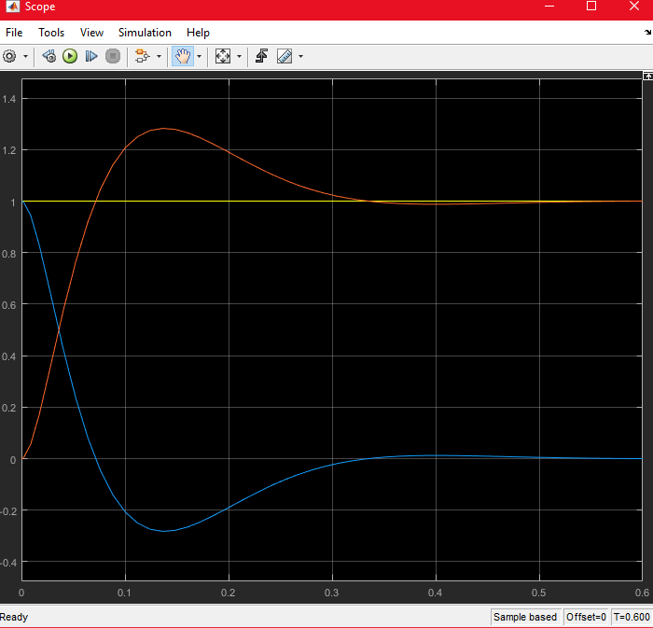

Figure Static Position error. Yellow: Input, Orange: Output, Blue: Error.

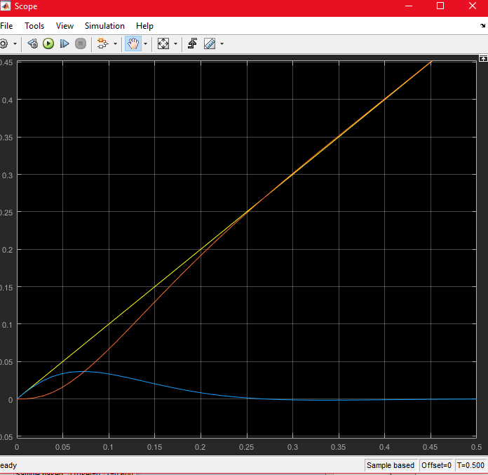

Figure Static Velocity Error. Yellow: Input, Orange: Output, Blue: Error

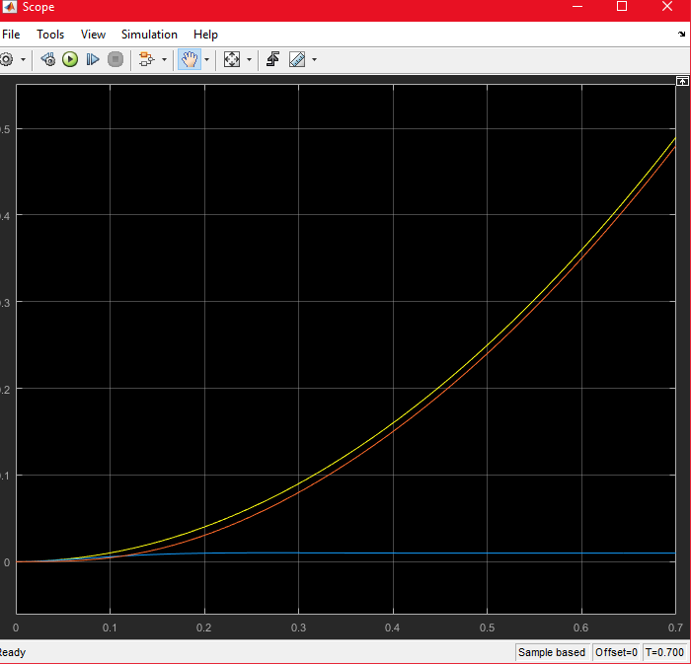

Figure Static Acceleration Error. Yellow: Input, Orange: Output, Blue: Error.

3 (a)

For and :

and

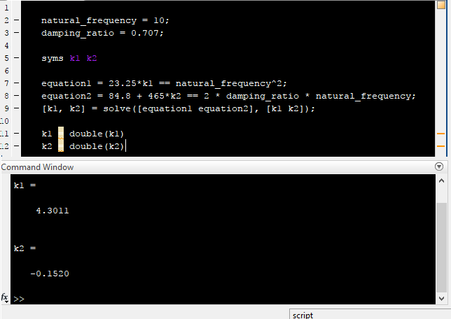

Figure Calculation of K1 and K2

(b)

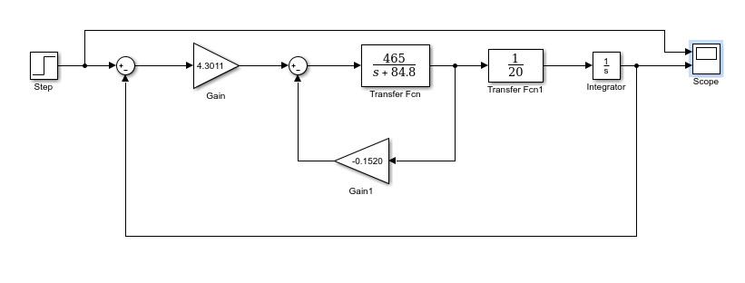

Figure Simulink setup for finding the desired information

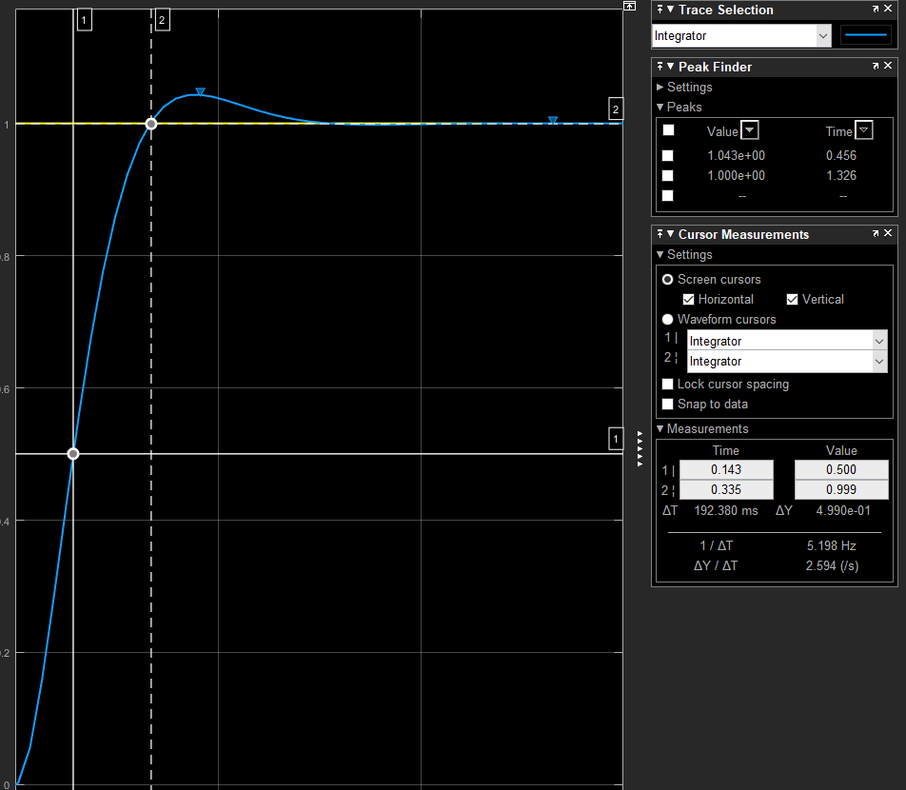

Figure Simulink graph with td, tr, tp, Mp and ωd measurements

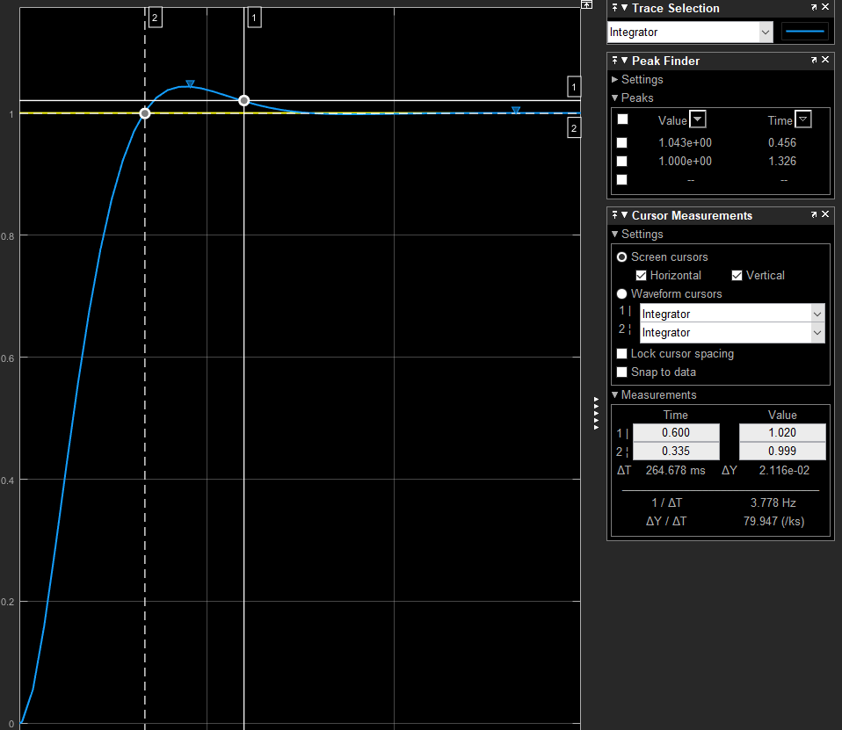

Figure Simulink Graph showing ts measurement

(c)

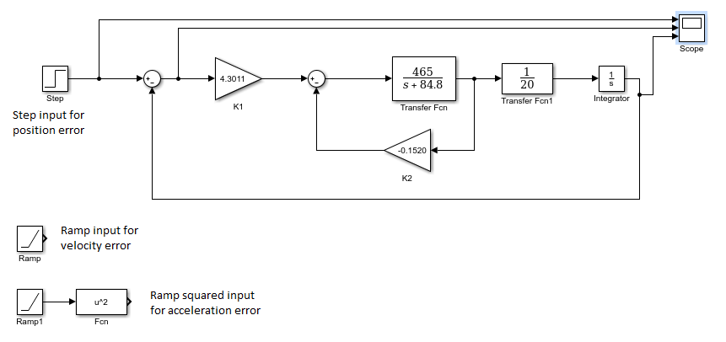

Figure Simulink diagram for static error plots

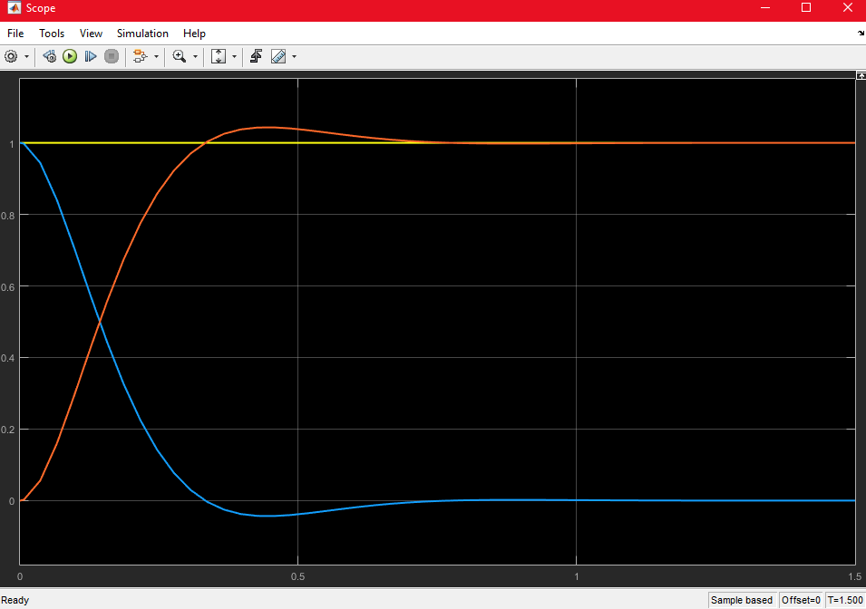

Figure Static Position error. Yellow: Input, Orange: Output, Blue: Error.

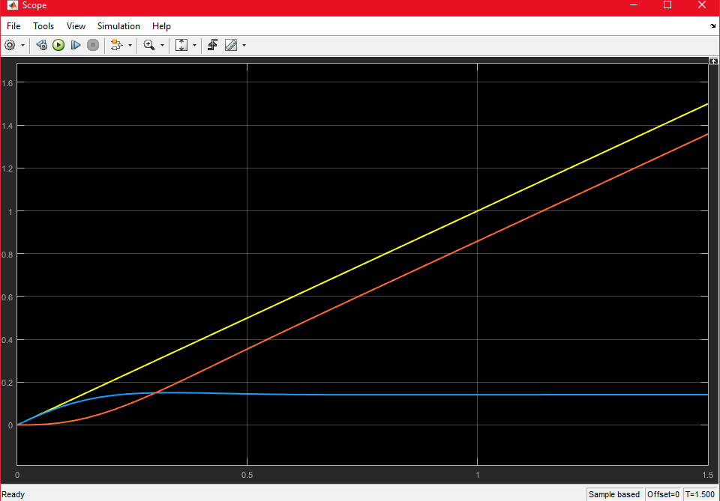

Figure Static Velocity error. Yellow: Input, Orange: Output, Blue: Error.

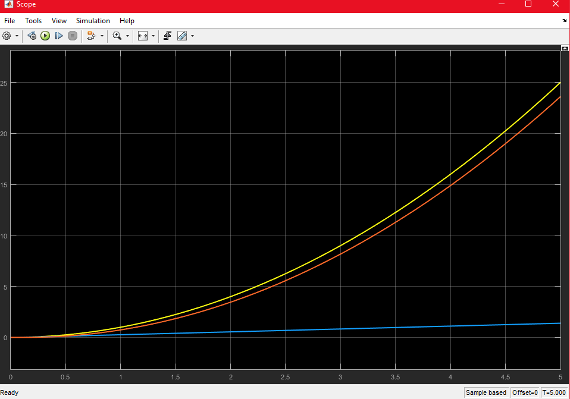

Figure Static Acceleration error. Yellow: Input, Orange: Output, Blue: Error.